16 – BIT MULTIPLICATION

# EXP NO-07

# AIM:

# To write an assembly language program to implement 16-Bit Multiplication using 8086 processor.

# 

# ALGORITHM:

# 1. Start the program by loading the first data into the accumulator.

# 2. Move the data to a register.

# 3. Get the second data and load it into the accumulator.

# 4. Add the two register contents.

# 5. Check for carry.

# 6. Store the value of sum and carry in the memory location.

# 7. Halt.

# PROGRAM:

LHLD 8500

SPHL

LHLD 8502

XCHG

LXI H,0000H

LXI B,000OH

AGAIN: DAD SP

JNC START

INX B

START: DCX D

MOV A,E

ORA D

JNZ AGAIN

SHLD 8504

MOV L,C

MOV 8506

HLT

# INPUT:

# 

OUTPUT:

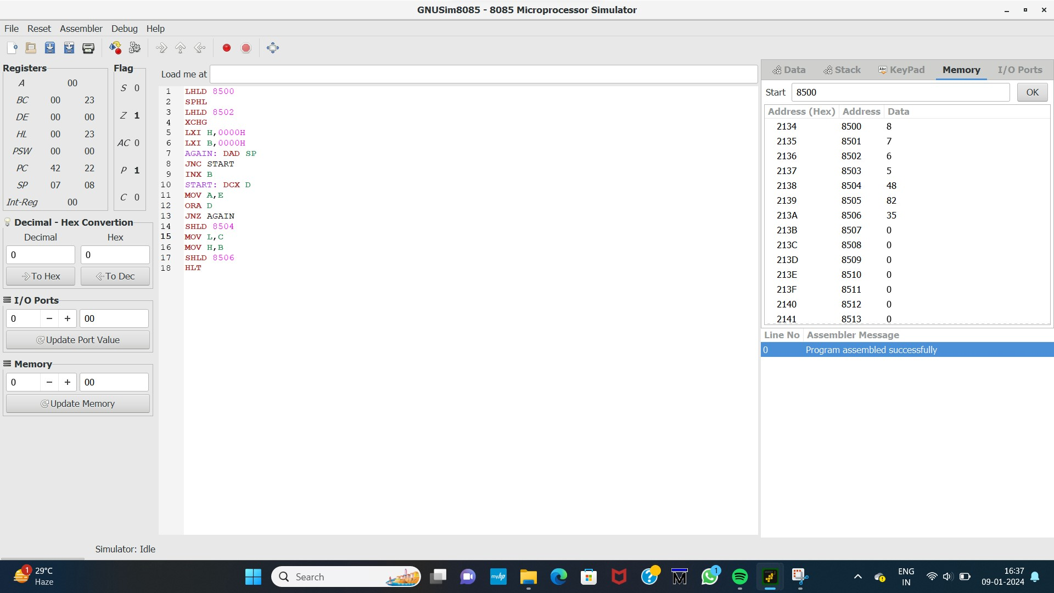

# RESULT:

Thus the program was executed successfully using 8086 processor stimulator.